Mrs. Elizabeth, Mrs. Leslie, Mrs. Kelly
& Mrs. Daphne’s Weekly Buzz
September 14-18, 2020
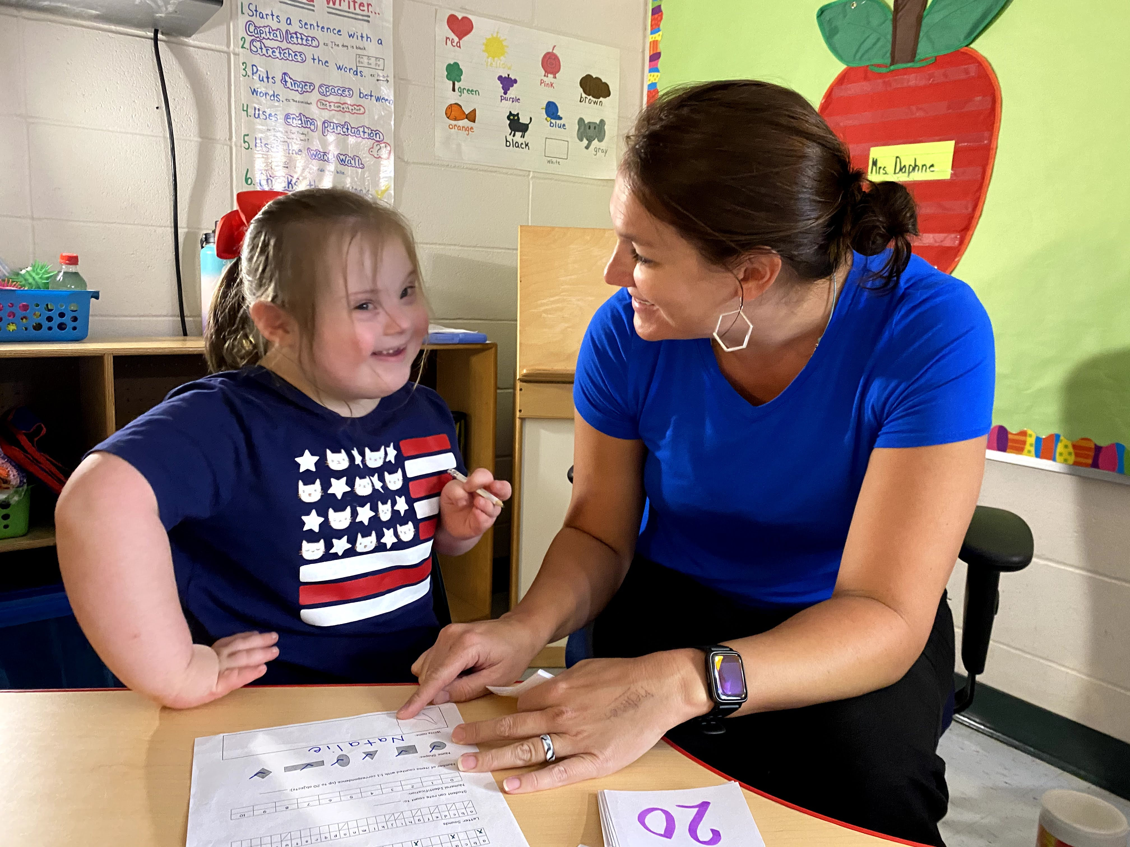
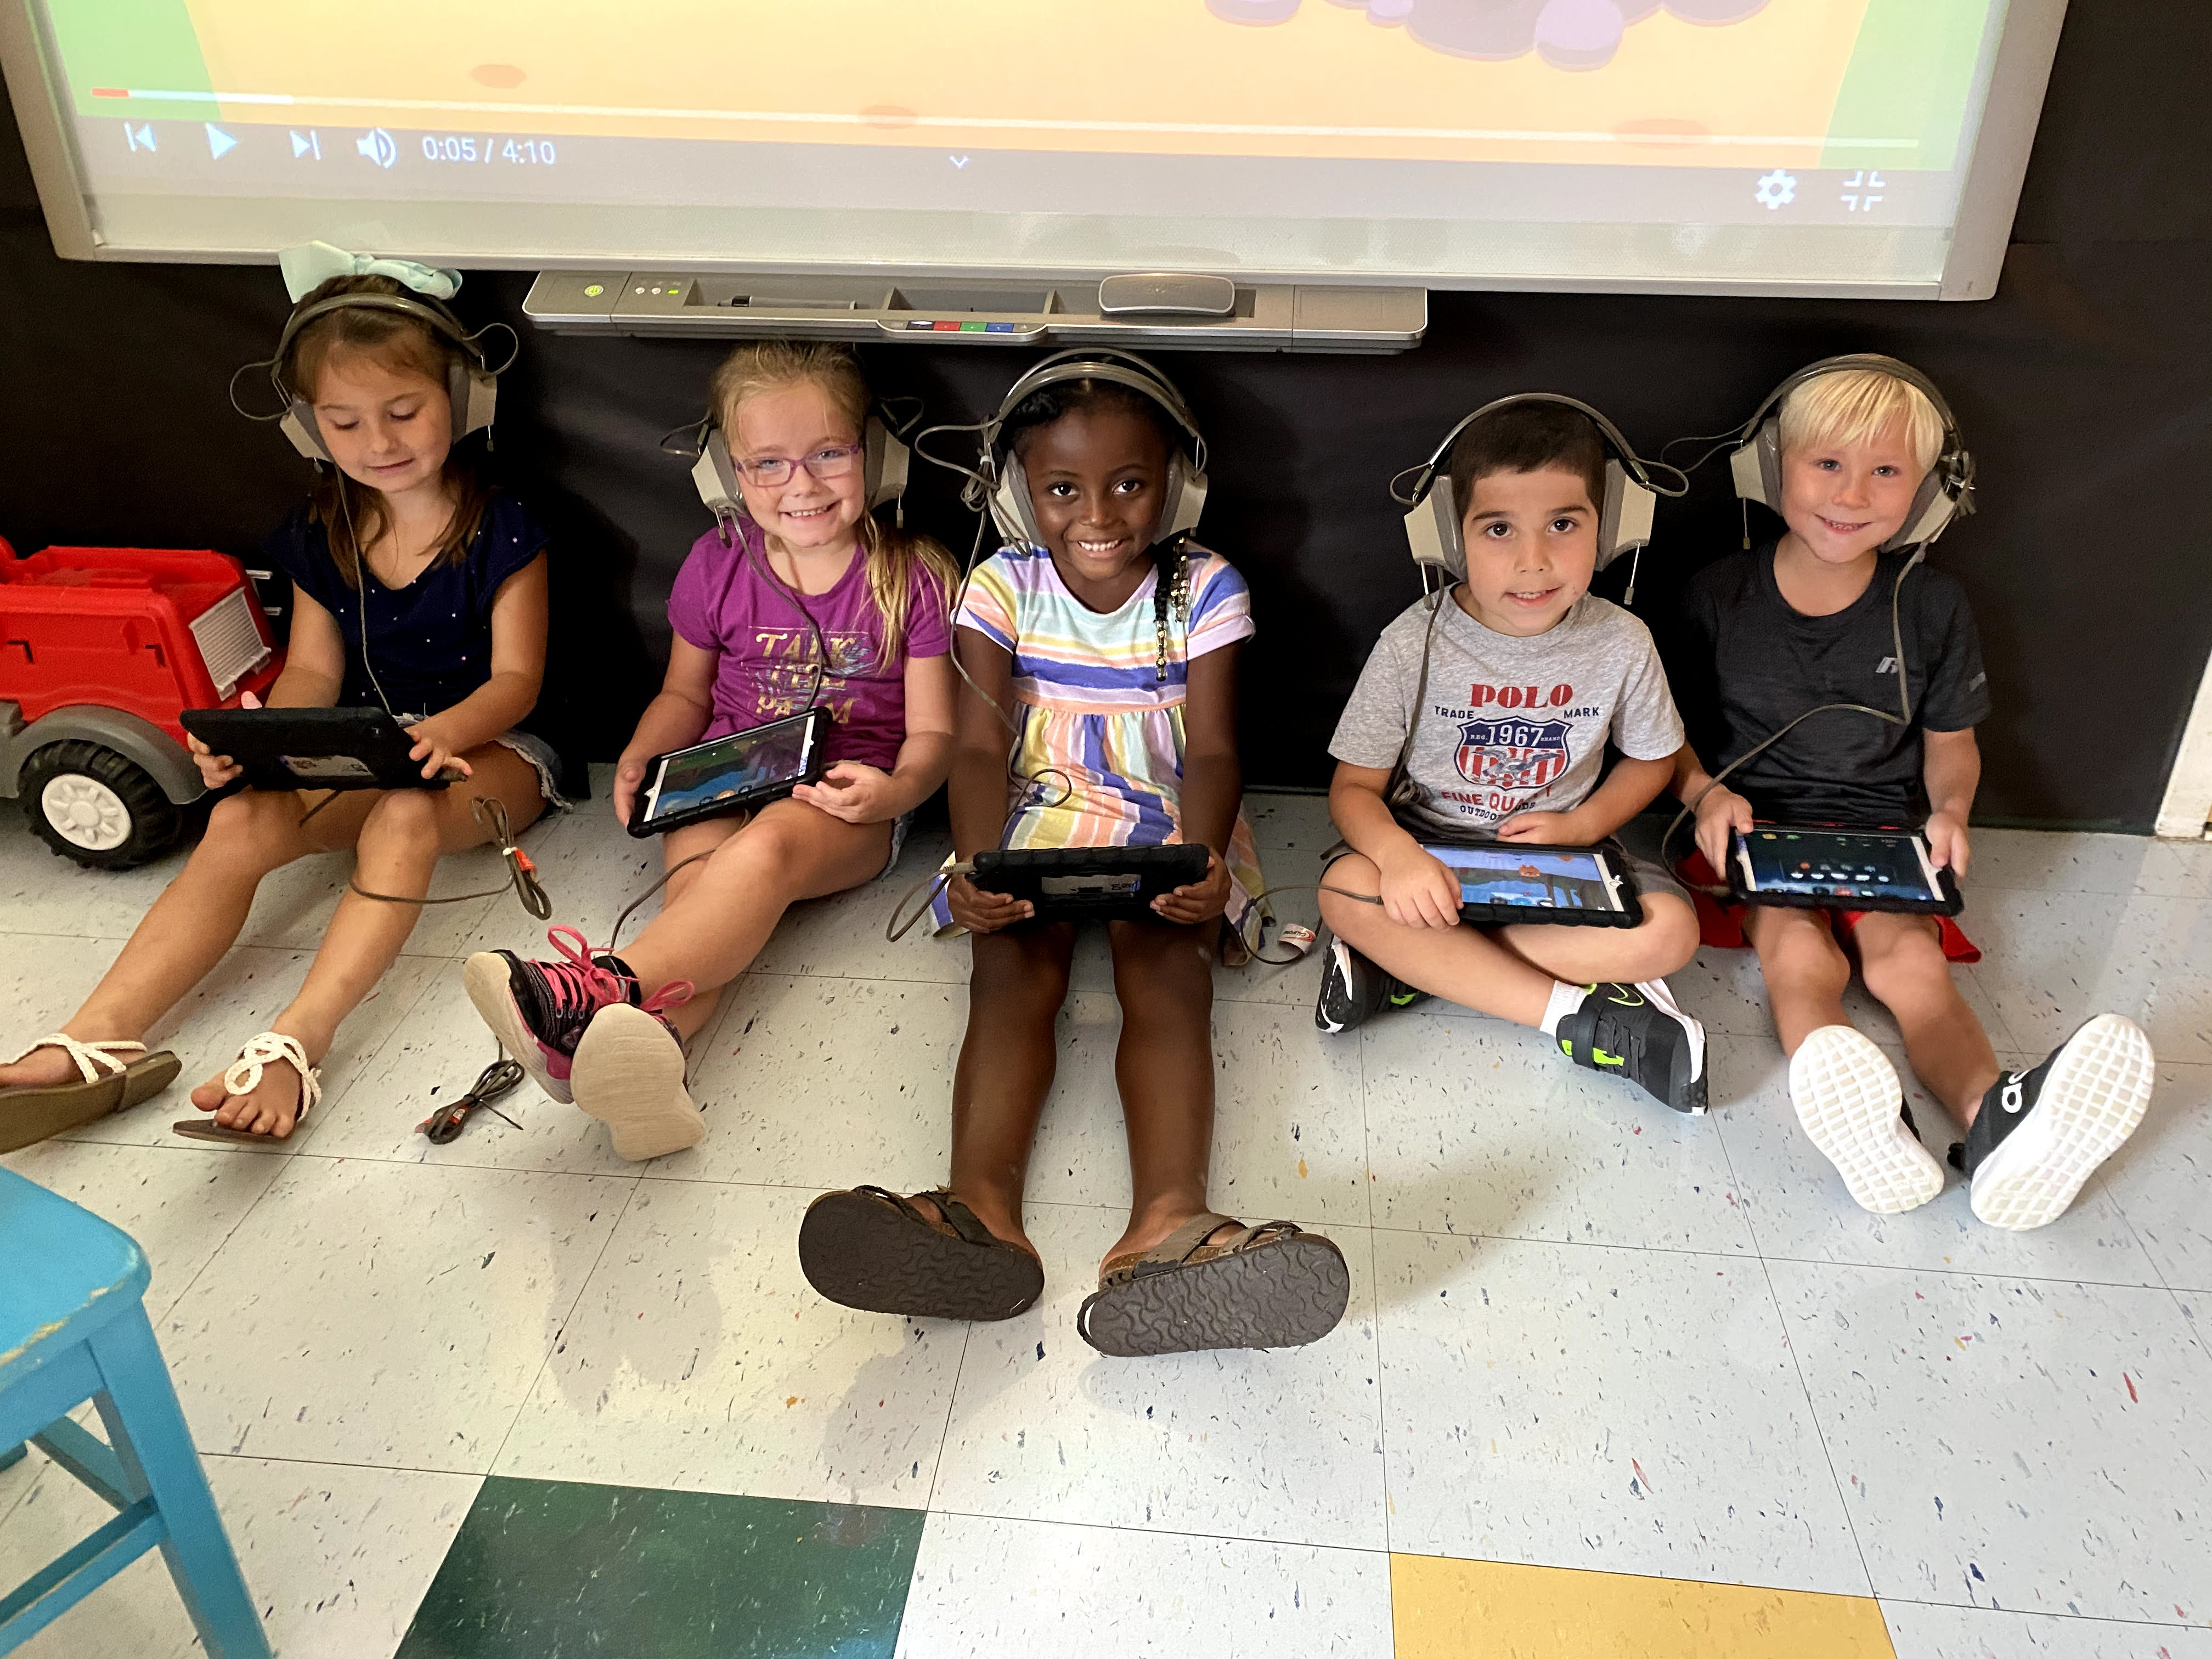
Math Skills
This week we have been working on counting to 20 by ones. We have also been practicing naming shapes.
What we’ve been reading…
During each story throughout the week we have been learning new vocabulary words. We’ve searched for the new words in each book, have discussed their meanings, and used them in sentences.

Rosie’s Walk
New Vocabulary: flour, haystack, mill, beehive

Frederick
New Vocabulary: abandoned, anxiously

After reading both books, we learned what it means to give your opinion about a topic. Then we learned how to make a complete sentence and draw a picture to match our sentence.

Don’t forget to send in a water bottle and mask for your little one each day!
This week we…
We have really been focusing on rituals and routines in the classroom. We reviewed classroom rules, ways to be a good friend, and good choices vs. bad choices. We have also been learning how to use classroom materials the correct way.

